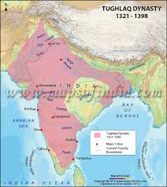**MUHAMMAD TUGHLUQ**

**1 .** RAISING THE TAXES IN DOAB

* Muhammad raised land tax in Doab a very fertile area, to fifty percent of the produce at a time when the entire region was in the grip of famine . This caused widespread discontent among the peasants of the area.
* TRANSFER OF CAPITAL FROM DELHI TO DAULATABAD : According to Barani, MBT was motivated to transfer the capital from Delhi to Daulatabad because he believed that Daulatabad was more centrally located and was equidistant from Delhi, Gujarat, Malabar.
* INTRODUCTION OF TOKEN CURRENCY

MBT introduced a token currency of bronze coins to be used in place in silver coins called tanka. This experiment was a total failure . Soon the silver coins disappeared from the market and forged coins made by people at their homes came into circulation. Too many forged coins created havoc in the market and the situation went out of control. He had to withdraw the currency and compensate the sufferers.